* **Pods**

Pod is the smallest deployable unit of computing. It represents a group of one or more containers, along with shared resources like storage and network, and specific instructions on how to run those containers. Essentially, a pod acts as a logical host for those containers, ensuring they run together on the same node and share resources.

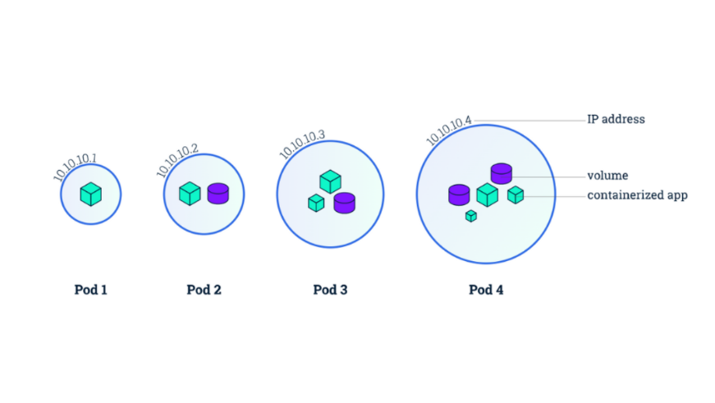

* **Replication Control/ ReplicaSet**

Replication controller helps to run the multiple instances of the same pod in the Kubernetes Cluster.

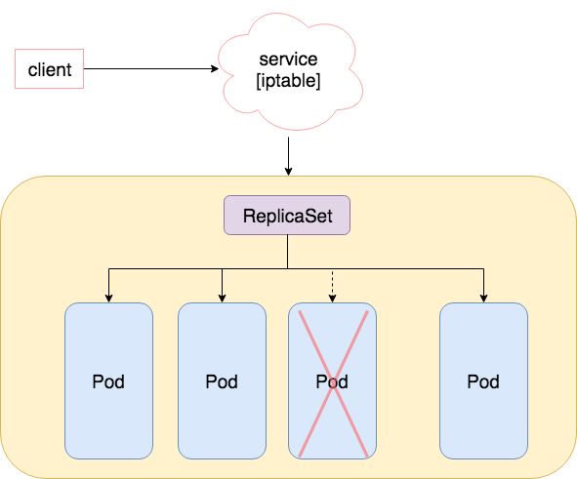

* **Namespace**

A namespace is a logical cluster within a physical Kubernetes cluster. It provides a way to divide cluster resources into virtual clusters, allowing multiple teams or projects to share a single cluster while maintaining logical isolation**.**

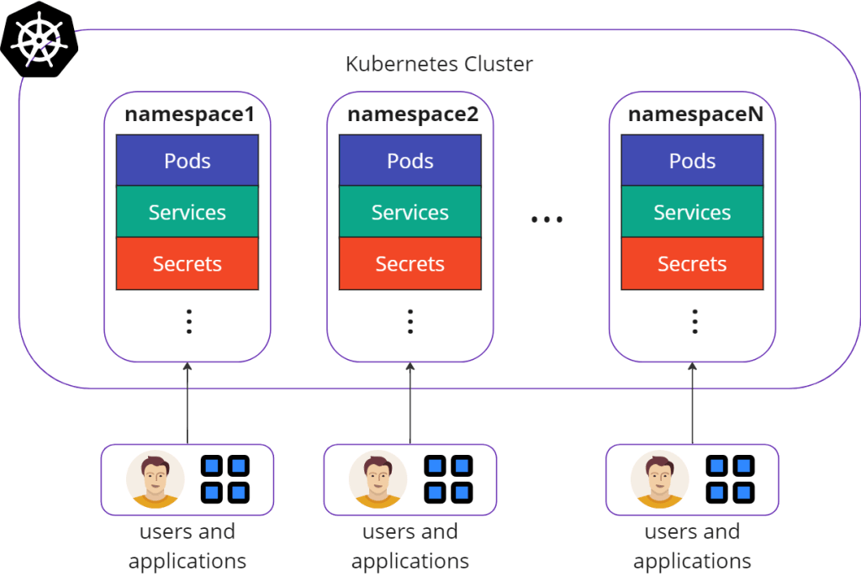

* **Update and Rollback (Deployment)**

When the deployment is created it also creates a rollout and versioning of that deployment, like, versioning. (Ex, Revison-1 Nginx 1.01) (Revison-2 Nginx1.02)

There are multiple deployment strategies, 1. Recreate strategy – Delete old deployment version and recreate new one.

2. Rolling update strategy – We will take down the older version and bring up the newer version one by one. ( This is the default strategy of the Deployment)

When we start upgrade the application its automatically create a 2-replication set, and its initiate the rolling update on the new ReplicaSet.

Here are the Kubernetes kubectl commands for the operations you mentioned:

**✅ 1. Get Deployments**

List all deployments in the current namespace:

**kubectl get deployments**

**🔄 2. Apply Manifest File**

Apply a YAML file to create or update a deployment:

**kubectl apply -f <deployment.yaml>**

**🔧 3. Set Image on Deployment**

Update the container image of a deployment:

**kubectl set image deployment/<deployment-name> <container-name>=<new-image>**

Example:

kubectl set image deployment/nginx-deployment nginx=nginx:1.25

**📊 4. Check Rollout Status**

Check the status of a deployment rollout:

**kubectl rollout status deployment/<deployment-name>**

**🔁 5. Undo/Roll Back a Deployment**

Rollback a deployment to the previous revision:

**kubectl rollout undo deployment/<deployment-name>**

Rollback to a specific revision (optional):

**kubectl rollout undo deployment/<deployment-name> --to-revision=<revision-number>**

* **Networking**

With the help of Cluster Networking, we can enable internal communication with different pods and nodes.

We use the tool at the Cluster level, Cisco Aci, cilium, flannel, calico, NSX-t – this create the Virtual network for all the pods and nodes using simple routing technique.

* **Servies and Its Types.**

1. Service – Node Port

The service node port makes internal pods accessible to the node and the end user **with the help of Port number**.

1. Service – Cluster IP.

It creates **Virtual IP inside the cluster** to communicate with the services and the front end and backup end servers.

1. Loan balancer –